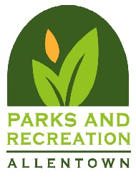

Our insurance requirements are as follows:

- Please provide us with a copy of your Certificate of Liability Insurance naming the City of Allentown as the additional insured in the amount of $1,000,000. The Certificate Holder needs to read:

City of Allentown
c/o Parks & Recreation
435 Hamilton St.
Allentown, PA 18101

- It is the renter’s responsibility to provide insurance. The City does not recommend a particular vendor.

- Please be sure to list all rental dates in the “Description” section.

- We also require “liquor liability“ or “host liquor” to be designated for any event using alcohol.

- Also, as part of the insurance, we will need a copy of the Additional Insured Endorsement Page in ADDITION to the certificate of liability insurance, naming the City of Allentown as the additional insured.

- Insurance is due NO LATER THAN 30 days before your event start date.

No event can occur without these two (2) documents. We thank you in advance for your understanding on this matter.

Thank you,

The Parks and Recreation Department

